Supplementary material
Additional file 1
Table S1. Statistics analysis on the leaf size of R. tanguticum at different ages.
 | Growth year | F | d.f. | P
Length | 1 to 2-year vs 3 to 4-year | 156.444 | 1,58 | < 0.001
 | 3 to 4-year vs over 5-year | 434.439 | 1,58 | < 0.001
 | 1 to 2-year vs over 5-year | 781.123 | 1,59 | < 0.001
Width | 1 to 2-year vs 3 to 4-year | 108.186 | 1,58 | < 0.001
 | 3 to 4-year vs over 5-year | 467.831 | 1,58 | < 0.001
 | 1 to 2-year vs over 5-year | 802.795 | 1,59 | < 0.001
One-way ANOVA analyses were performed with an alpha level of 0.01 or 0.05, and provided with the following F values (F) and degrees of freedom (d.f.).

Table S2. Summary of statistical analysis on the temperature of opposite parts of leaf.
 | t | d.f. | P
Tip | 4.513 | 1,14 | < 0.001
Central | 0.855 | 1,14 | 0.407
Base | 1.232 | 1,14 | 0.238
Sun-exposed vs shaded | 14.328 | 1,54 | < 0.001
Highest vs lowest | 53.256 | 1,159 | < 0.001
Paired-samples T-tests were used to analyze the temperature of opposite parts of leaf (right and left sides of the midrib, i.e., sun-exposed and shaded part), and highest vs lowest temperature of one thermal imaging of R. tanguticum leaf. The following t values (t) and degrees of freedom (d.f.) were provided. The P values were based on two-tailed permutation tests.

Additional file 2: Figure S1 A spliced leaf from an over 5-year old R. tanguticum plant.
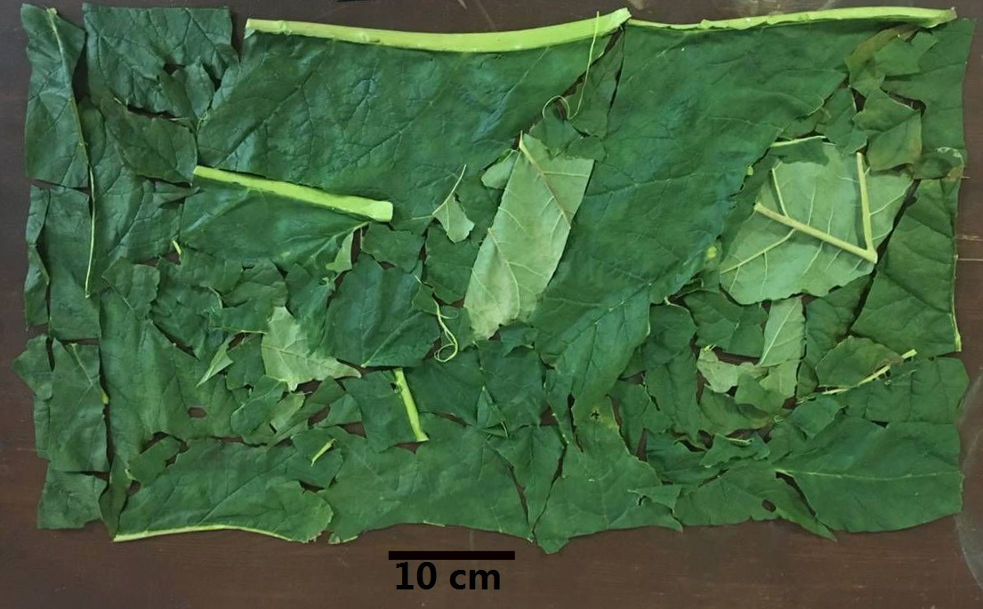

Additional file 3: Figure S2 Different temperatures detected from the opposite sides of the midrib. (A) leaf tip; (B) leaf central; (C) leaf base.

Additional file 4: Figure S3 Temperatures of the opposite sides of the midrib. (a) leaf tip; (b) leaf central; (c) leaf base.

Additional file 5: Figure S4 Temperatures of sun-exposed and shaded parts of the leaves. (a) ambient temperature at 14.60℃; (b) ambient temperature at 17.80℃.
Additional file 6: Video. Airflow indicated by smoke in the leaf.

